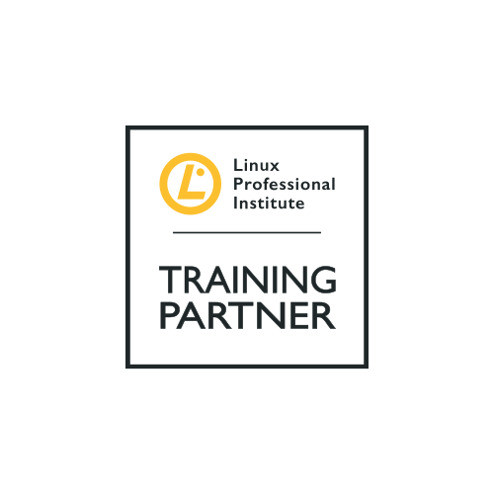

COURSE OUTLINE

Course Name: Linux Professional Institute LPIC-1

|  |  |  |  |  |
| --- | --- | --- | --- | --- |
| **DURATION** | **SKILL LEVEL** | **DELIVERY**  **METHOD** | **TRAINING**  **CREDITS** | **TECHNOLOGY** |
| 5 Days | Intermediate | Instructer-Led | N/A | Linux |

**Course Description:**

LPIC-2 is the second certification in the multi-level professional certification program of the Linux Professional Institute (LPI). The LPIC-2 will validate the candidate's ability to administer small to medium–sized mixed networks.In addition learners attending this course will be taught the Linux kernel, system startup, advanced storage, network configuration, system maintenance, web services, security and troubleshooting.

**Prerequisites:**

The candidate must have an active LPIC-1 certification to receive the LPIC-2 certification.

**Target Audience:**

This course is designed for Linux professionals with good working knowledge of Linux System Administration.

**Learning Objectives:**

To become LPIC-2 certified the candidate must be able to:

* Perform advanced system administration, including common tasks regarding the Linux Kernel, system startup and maintenance;
* Perform advanced Management of block storage and file systems as well as advanced networking and authentication and system security, including firewall and VPN;
* Install and configure fundamental network services, including DHCP, DNS, SSH, Web servers, file servers using FTP, NFS and Samba, email delivery;
* Supervise assistants and advise management on automation and purchases.

**Course Outline:**

**Lesson 1: Capacity Planning System**

* Measure and Troubleshoot Resource Usage
* Predict Future Resource Needs

**Lesson 2: Linux Kernel**

* Kernel Components
* Compiling a Kernel
* Kernel runtime management and troubleshooting

**Lesson 3: System Startup**

* Customizing SysV-init system startup
* System Recovery
* Alternate Bootloaders

**Lesson 4: Filesystem and Devices**

* Operating the Linux filesystem
* Maintaining a Linux filesystem

**Lesson 5: Advanced Storage Device Administration**

* Configuring RAID
* Adjusting Storage Device Access
* Logical Volume Manager

**Lesson 6: Network Configuration**

* Basic Network Configuration
* Advanced Network Configuration and Troubleshooting
* Troubleshooting Network Issues

**Lesson 7: System Maintenance**

* Make and install programs from source
* Backup operations
* Notify users on system-related issues

**Associated Exam and Certification:**

This course will prepare students to take the LPIC-2 exams 201-450 and 202-450.

Successfully passing both these exams will result in the attainment of the Linux Professional Institute LPIC-2 certification.

After completing this course, students will receive a Netcampus course attendance certification.

**Exams and Certifications**

**Notes and Annotations**

**What is Next**

**Exams and Certifications**

**Follow on Course:**

Link to the next recommended course -link to course on website